GASB 68 Guide
New Mexico Educational Retirement Board
For the Fiscal Year Ended June 30, 2018

Disclaimer

The purpose of this guide is to assist employers who are participants in the Educational Retirement Plan administered by the New Mexico Educational Retirement Board (NMERB) to comply with the accounting and reporting requirements in the Governmental Accounting Standards Board’s Statement No. 68, Accounting and Financial Reporting for Pensions (GASB 68), as amended.

The information provided by this guide and the tools included with this guide do not constitute, and should not be treated as, professional advice. As guidance, the information and tools are only the starting point for an employer and its auditors to independently determine the accuracy and completeness of the pension related information that is reported in the employer’s audited financial statements.

Contents
Introduction 1
Section 1: GASB 68 Requirements and the Journal Entry Tool 2
Section 2: How to Use the JE Tool 4
Section 3: GASB 68 Disclosure Template 7

Introduction

As of June 30, 2018, the Governmental Accounting Standards Board’s Statement No. 68, Accounting and Financial Reporting for Pensions (GASB 68) will have been effective for four years. Since employers are now familiar with GASB 68’s requirements, this guide does not focus on the basic requirements of GASB 68; instead, it provides two tools to make the required accounting and reporting easier. The following is a description of the tools.
The JE Tool generates journal entries. An employer can use the entries as a guide to record changes in the employer's pension liabilities and pension expense for the fiscal year. To generate the entries, the tool uses the employer specific information in the Schedules of Employer Allocations and Pension Amounts by Employer published annually by the New Mexico Educational Retirement Board (NMERB). The tool requires a minimum amount of data entry by the employer.
The entries the tool generates are generic; however, an employer can use them as a guide to prepare customized entries that are consistent with employer’s chart of accounts and accounting processes. The tool also generates a summary that the employer can use as an internal control aide to help insure the completeness and accuracy of the amounts to be recorded and reported.
The other tool provided as part of this guide is the GASB 68 Disclosure Template. It provides sample pension related financial statement notes and required supplementary information (RSI) schedules (including related notes). The template includes the disclosures generally applicable to all participating employers. Employer specific information is highlighted to tell the employer what to customize in the template. Next to each highlight are instructions on where to find the information needed to customize the template.
Before proceeding, if you are not familiar with GASB 68, we suggest you first read GASB 68 and GASB’s A Plain-English Guide to Deferrals. In addition, we suggest you read NMERB’s Employer Primer GASB 68 Implementation in Fiscal Year 2015.

Section 1: GASB 68 Requirements and the Journal Entry Tool
In general, GASB 68 requires an employer to record the following:
- The employer’s proportionate share of the change in collective deferred outflows of resources.
- The employer’s proportionate share of the change in collective deferred inflows of resources.
- The employer’s proportionate share of collective pension expense.
- Employer-level deferral for the change in the employer allocation percentage.
- Amortization of employer-level deferrals for change in the employer allocation percentage.
- Employer-level deferral for the difference between actual contributions and a proportional share of total contributions for the pension plan measurement date.
- Amortization of employer-level deferrals for the difference between actual contributions and a proportionate share of total contributions.
- Deferral of the employer contributions between the measurement date and the reporting date.
The Journal Entry Tool (JE Tool) summarizes the accounting requirements listed above into four journal entries. Figure 1 illustrates the tool’s summary entries and the accounts the entries impact. (Figure 1 is available for download in an Excel® worksheet format from NMERB’s Web Site.)
How to use the JE Tool is explained in Section 2 below, using Albuquerque Public Schools as an example.

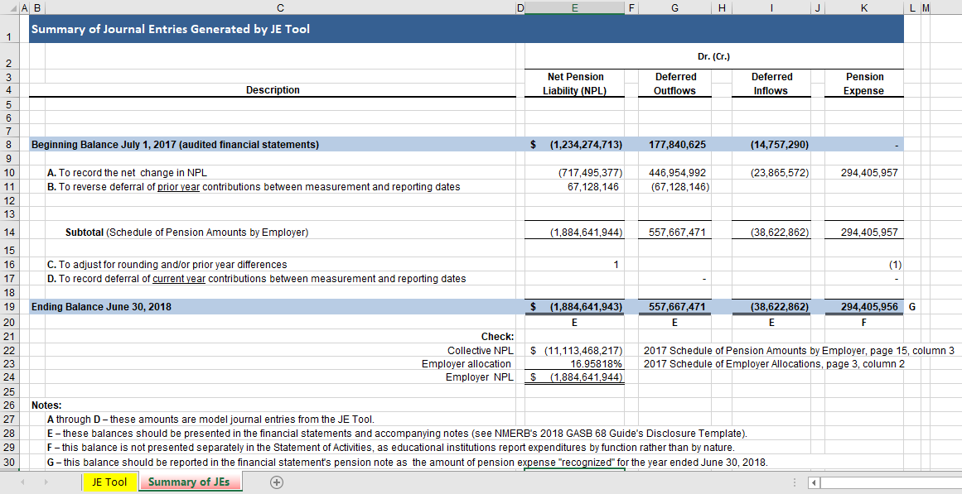
Figure 1: Summary of Journal Entries Generated by JE Tool

Section 2: How to Use the JE Tool
The JE Tool is in an Excel® workbook. You can download the workbook to your computer from NMERB’s Web Site. Once you download the workbook, open the worksheet named JE Tool, and you are ready to begin using the tool. Figure 2 below illustrates the data entry section of the JE Tool.
To use the tool, all you need to do is fill in the cells that have green borders. Next to each of these cells are the instructions on where to find the employer specific data. Entering the data into the ten cells is all you need to do: the tool will take the data you entered and use it to generate the required journal entries and the summary schedule included with the tool (see Figure 1).
Figure 2 Data Entry Required
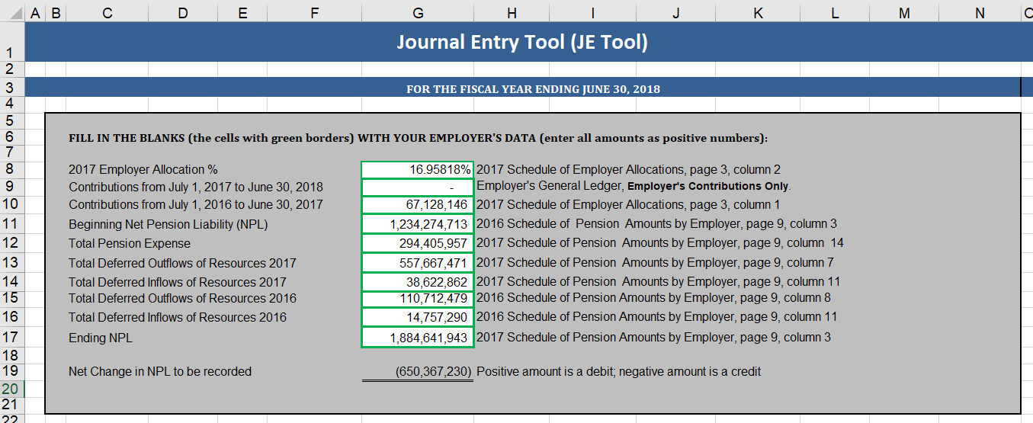
All the data is available from schedules in the Schedules of Employer Allocations and Pension Amounts by Employer which can be downloaded from NMERB’s Web Site.

Figure 3 illustrates two of the journal entries the tool generates.
Figure 3 Sample Journal Entries
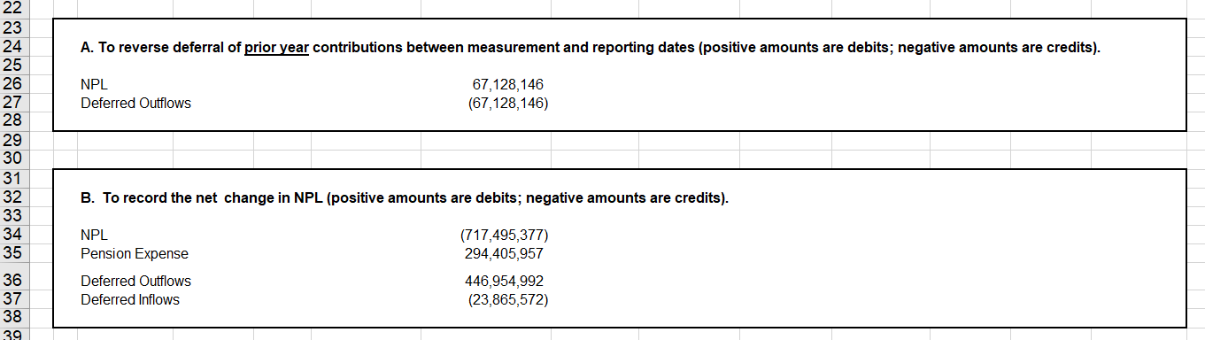
Notice that the account descriptions are generic. Also, the accounts are probably at a higher level of summary than your chart of accounts. For example, your chart of accounts may classify pension expense into different instructional expenditure categories. If the tool’s accounts are at a higher summary level, use the tool’s entries as check totals for the more detailed entries you will need to prepare.
In addition, you may have to pick and choose from the tool’s entries, depending on your accounting processes. For example, if as part of your routine accounting processes, you defer contributions between the measurement date and the reporting date (instead of recording them as expenditures), you will not need to record Adjustment D. However, you should still use the entry to verify the amounts you have recorded.
Verifying balances is very important; accordingly, regardless of the chart of accounts you use and the chart’s summary level, make sure that the balances you report in your fiscal year 2018 audited financial statements equal the balances the tool shows.
The JE Tool calculates and provides Adjustment C for rounding and/or prior year differences. If you followed last fiscal year’s (for June 30, 2017) GASB 68 guide, you should not have any prior year differences and rounding difference should be under $5.
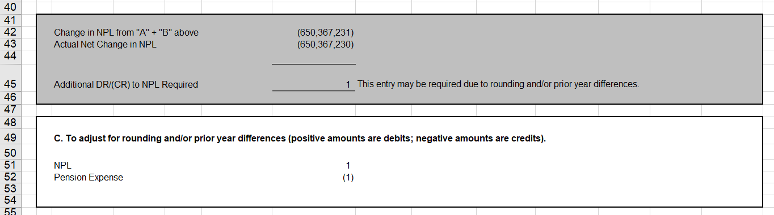
Figure 4 Adjustment for Differences
Don’t forget to record Adjustment D. The example in this guide shows zero debits and credits in Adjustment D because the guide was published before the end of this fiscal year. Following the end of the fiscal year, you should obtain the amount of employer contributions subsequent to the measurement date from your employer’s records and enter the amount in the JE Tool (cell “G9”). Figure 5 below illustrates where to enter the amount.
Figure 5 Entering Contributions Subsequent to the Measurement Date
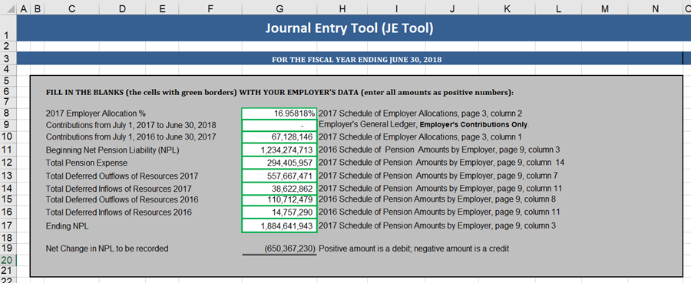

Section 3: GASB 68 Disclosure Template

Disclaimer: The sample financial statement notes and required supplementary information (RSI) below are based on the illustrations in GASB’s Guide to Implementation of GASB Statement 68 on Accounting and Financial Reporting for Pensions. The sample is not and should not be treated as professional advice. The sample includes only commonly required employer disclosures; accordingly, employers should consult with their independent public accountants for specific financial statement presentations.

Introduction

The GASB 68 Disclosure Template follows this introduction. Specific employer information that you need to enter is highlighted in yellow. [Red text] enclosed in brackets directs you to where that information can be found. [Blue text] enclosed in brackets provides either general guidance or guidance on additional disclosures that may be required.

This guide is provided as a Microsoft Word® document so that you can easily copy the GASB 68 Disclosure Template to the word processing or publishing document you are using to draft your financial statements. If you do copy the template into your document, please note the following:
- The template does not have headers or footers; they were omitted to enable you to easily add headers and footers that are consist with your draft.
- The red text is for information only and should be deleted in your draft.
- The blue text is only applicable to certain situations. If those situations do not apply to your employer, delete the blue text. If the situations do apply, include in your draft the required disclosures and delete all other blue text.
- The schedules in the template are Word® tables to facilitate publishing. However, if you change the font in the tables, you may have to change the default size of the table cells. If you are not familiar with how to format Word® table cells, we highly recommend you use the tables as they are—or recreate them in Excel® and copy and paste them into your document. (For publishing, a Word® table results in much clearer text than pasting the table from Excel®, which usually distorts the text, especially when the table is reduced to fit in a Word® document.)

Template

Employer Name
Notes to the Financial Statements
for the Year Ended June 30, 2018
(Dollar amounts in thousands)

Note 1. Summary of Significant Accounting Policies

[The following should be included in the Summary of Significant Accounting Policies.]

Pensions: For purposes of measuring the net pension liability, deferred outflows of resources and deferred inflows of resources related to pensions, and pension expense, information about the fiduciary net position of the Educational Retirement Plan (ERP) and additions to/deductions from ERP’s fiduciary net position have been determined on the same basis as they are reported by ERP. For this purpose, benefit payments (including refunds of employee contributions) are recognized when due and payable in accordance with the benefit terms. Investments are reported at fair value.

Note X. Pension Plan

[If the employer provided benefits to employees through two or more pension plans, the employer should disclose information required by paragraph 74 of Statement 68 and should apply the requirements of paragraph 75 of Statement 68.]

General Information about the Pension Plan

Plan description – The New Mexico Educational Retirement Act (ERA) was enacted in 1957. The act created the Educational Employees Retirement Plan (Plan) and, to administer it, the New Mexico Educational Retirement Board (NMERB). The Plan is included in NMERB’s comprehensive annual financial report. The report can be found on NMERB’s Web site at https://www.nmerb.org/Annual_reports.html .
The Plan is a cost-sharing, multiple-employer pension plan established to provide retirement and disability benefits for certified teachers and other employees of the state’s public schools, institutions of higher learning, and state agencies providing educational programs. Additional tenets of the ERA can be found in Section 22-11-1 through 22-11-52, NMSA 1978, as amended.
The Plan is a pension trust fund of the State of New Mexico. The ERA assigns the authority to establish and amend benefit provisions to a seven-member Board of Trustees (Board); the state legislature has the authority to set or amend contribution rates and other terms of the Plan. NMERB is self-funded through investment income and educational employer contributions. The Plan does not receive General Fund Appropriations from the State of New Mexico.
All accumulated assets are held by the Plan in trust to pay benefits, including refunds of contributions as defined in the terms of the Plan. Eligibility for membership in the Plan is a condition of employment, as defined in Section 22-11-2, NMSA 1978. Employees of public schools, universities, colleges, junior colleges, technical-vocational institutions, state special schools, charter schools, and state agencies providing an educational program, who are employed more than 25% of a full-time equivalency, are required to be members of the Plan, unless specifically excluded.
Pension Benefit – A member’s retirement benefit is determined by a formula which includes three component parts: 1) the member’s final average salary (FAS), 2) the number of years of service credit, and 3) a 0.0235 multiplier. The FAS is the average of the member’s salaries for the last five years of service or any other consecutive five-year period, whichever is greater.
Summary of Plan Provisions for Retirement Eligibility – For members employed before July 1, 2010, a member is eligible to retire when one of the following events occurs:
- The member’s age and earned service credit add up to the sum of 75 or more,
- The member is at least sixty-five years of age and has five or more years of earned service credit, or
- The member has service credit totaling 25 years or more.
Chapter 288, Laws of 2009 changed the eligibility requirements for new members first employed on, or after, July 1, 2010 and before July 1, 2013. The eligibility for a member who either becomes a new member on or after July 1, 2010 and before July 1, 2013, or at any time prior to July 1, 2010 refunded all member contributions and then becomes re-employed after July 1, 2010 is as follows:

- The member’s age and earned service credit add up to the sum of 80 or more,
- The member is at least sixty-seven years of age and has five or more years of earned service credit, or
- The member has service credit totaling 30 years or more.
Section 2-11-23.2, NMSA 1978 added eligibility requirements for new members who were first employed on or after July 1, 2013, or who were employed before July 1, 2013 but terminated employment and subsequently withdrew all contributions, and returned to work for an ERB employer on or after July 1, 2013. These members must meet one of the following requirements.
- The member’s minimum age is 55, and has earned 30 or more years of service credit. Those who retire earlier than age 55, but with 30 years of earned service credit will have a reduction in benefits to the actuarial equivalent of retiring at age 55.
- The member’s minimum age and earned service credit add up to the sum of 80 or more. Those who retire under the age of 65, and who have fewer than 30 years of earned service credit will receive reduced retirement benefits
- The member’s age is 67, and has earned 5 or more years of service credit.
Forms of Payment – The benefit is paid as a monthly life annuity with a guarantee that, if the payments made do not exceed the member’s accumulated contributions plus accumulated interest, determined as of the date of retirement, the balance will be paid in a lump sum to the member’s surviving beneficiary.
Benefit Options – The Plan has three benefit options available.
- Option A – Straight Life Benefit – The single life annuity option has no reductions to the monthly benefit, and there is no continuing benefit due to a beneficiary or estate, except the balance, if any, of member contributions plus interest less benefits paid prior to the member’s death.
- Option B – Joint 100% Survivor Benefit – The single life annuity monthly benefit is reduced to provide for a 100% survivor’s benefit. The reduced benefit is payable during the life of the member, with the provision that, upon death, the same benefit is paid to the beneficiary for his or her lifetime. If the beneficiary predeceases the member, the member’s monthly benefit is increased to the amount the member would have received under Option A Straight Life benefit. The member’s increased monthly benefit commences in the month following the beneficiary’s death.
- Option C – Joint 50% Survivor Benefit – The single life annuity monthly benefit is reduced to provide for a 50% survivor’s benefit. The reduced benefit is payable during the life of the member, with the provision that, upon death, the reduced 50% benefit is paid to the beneficiary for his or her lifetime. If the beneficiary predeceases the member, the member’s monthly benefit is increased to the amount the member would have received under Option A Straight Life benefit. The member’s increased monthly benefit commences in the month following the beneficiary’s death.
Disability Benefit – An NMERB member is eligible for disability benefits if they have acquired at least ten years of earned service credit and is found totally disabled. The disability benefit is equal to 2% of the member’s Final Average Salary (FAS) multiplied by the number of years of total service credits. However, the disability benefit shall not be less than the smaller of (a) one-third of the member’s FAS or (b) 2% of the member’s FAS multiplied by total years of service credit projected to age 60.
Cost of Living Adjustment (COLA) – All retired members and beneficiaries receiving benefits receive an automatic adjustment in their benefit on July 1 following the later of 1) the year a member retires, or 2) the year a member reaches age 65 (Tier 1 and Tier 2) or age 67 (Tier 3).
- Tier 1 membership is comprised of employees who became members prior to July 1, 2010
- Tier 2 membership is comprised of employees who became members after July 1, 2010, but prior to July 1, 2013
- Tier 3 membership is comprised of employees who became members on or after July 1, 2013
As of July 1, 2013, for current and future retirees the COLA is immediately reduced until the Plan is 100% funded. The COLA reduction is based on the median retirement benefit of all retirees excluding disability retirements. Retirees with benefits at or below the median and with 25 or more years of service credit will have a 10% COLA reduction; their average COLA will be 1.5%. Once the funding is greater than 90%, the COLA reductions will decrease. The retirees with benefits at or below the median and with 25 or more years of service credit will have a 5% COLA reduction; their average COLA will be 1.7%.
Members on disability retirement are entitled to a COLA commencing on July 1 of the third full year following disability retirement. A member on regular retirement who can prove retirement because of a disability may qualify for a COLA beginning July 1 in the third full year of retirement.
Refund of Contributions – Members may withdraw their contributions only when they terminate covered employment in the State and their former employer(s) certification determination has been received by NMERB. Interest is paid to members when they withdraw their contributions following termination of employment at a rate set by the Board. Interest is not earned on contributions credited to accounts prior to July 1, 1971, or for contributions held for less than one year.
[Employees of certain New Mexico universities and colleges (see “Eligibility” below) participate in the Alternative Retirement Plan. Those universities and colleges should disclose the following information about the plan:

Alternative Retirement Plan – Effective October 1991, the New Mexico legislature established an Alternative Retirement Plan (ARP) through the enactment of ERA Sections 22-11-47 through 52 NMSA 1978 to provide eligible employees an election to establish an alternative retirement investment plan. In contrast to the defined benefit plan administered by NMERB, the ARP is a defined contribution plan. NMERB is the trustee of the ARP which is administered by two third-party contractors for NMERB. The two administrators approved to offer ARP plans to eligible participants are Teachers Insurance and Annuity Association (TIAA) and Fidelity Investments.
These administrators have the authority to perform record keeping, enrollment education services, and other administrative duties for the ARP. The administrators are delegated any and all powers as may be necessary or advisable to discharge their duties under the ARP and have certain discretionary authority to decide matters under the ARP. As the ARP trustee NMERB is responsible for selecting investment options that provide a prudent rate of return, and to ensure that all investments, amounts, property, and rights under the executed Plan-Trust are held for the exclusive benefit of Plan participants and their beneficiaries, as defined in the Plan Document.
Eligibility – Certain employees of the University of New Mexico, New Mexico State University, New Mexico Institute of Mining and Technology, New Mexico Highlands University, Eastern New Mexico University, Western New Mexico University, Central New Mexico Community College, Clovis Community College, Luna Community College, Mesalands Community College, New Mexico Junior College, Northern New Mexico College, San Juan College and Santa Fe Community College are eligible to make an election to participate within ninety days of employment. Information about the ARP is distributed by the employer. Those who do not elect to participate in the ARP remain members of the regular defined benefit retirement plan.
Section 22-11-47(D) NMSA 1978 allows an ARP participant a one-time option to make an irrevocable switch to the defined benefit retirement plan after seven years of ARP participation.
Form of Payment - Retirement, death, and other benefits are based upon contributions made and earnings accumulated on those contributions, in accordance with the terms of the applicable vendor contracts and Internal Revenue Service Code. Retirement benefits shall, at the option of the employee, be paid in the form of:
- A lifetime income, if held in an annuity contract,
- Payments for a term of years, or
- A single-sum cash payment.
ARP retirement, death, and other benefits, including disability benefits, cannot be paid from the funds administered by NMERB.
ARP Contributions - For the year ended June 30, 2017, colleges and universities contributed 10.90% of participating employees’ gross salary to the ARP vendor on behalf of the participant, and 3% of the employees’ gross salary to NMERB. The colleges and universities are responsible for submitting the balance of the employers’ contribution, and the employees’ contributions directly to the ARP vendors.
Employees participating in the ARP do not accrue rights to benefits in the defined benefit pension plan based on the 3% contributions to the Plan.
Employer contributions reported in the Statement of Changes in Fiduciary Net Position include amounts remitted on behalf of both the ARP defined contribution plan and the defined benefit plan. The 3% contribution remitted for fiscal years ended June 30, 2018 and 2017 were $X,XXX,XXX and $X,XXX,XXX respectively.(Employer’s general ledger)]

Contributions – For the fiscal years ended June 30, 2018 and 2017 educational employers contributed to the Plan based on the following rate schedule.

Fiscal  Year |  | Date Range |  | Wage  Category |  | Member  Rate |  | Employer  Rate |  | Combined  Rate |  | Increase Over Prior Year
2018 |  | 7-1-17 to 6-30-18 |  | Over $20K |  | 10.70% |  | 13.90% |  | 24.60% |  | 0.00%
2018 |  | 7-1-17 to 6-30-18 |  | $20K or less |  | 7.90% |  | 13.90% |  | 21.80% |  | 0.00%
2017 |  | 7-1-16 to 6-30-17 |  | Over $20K |  | 10.70% |  | 13.90% |  | 24.60% |  | 0.00%
2017 |  | 7-1-16 to 6-30-17 |  | $20K or less |  | 7.90% |  | 13.90% |  | 21.80% |  | 0.00%

The contribution requirements are established in statute under Chapter 10, Article 11, NMSA 1978. The requirements may be amended by acts of the New Mexico Legislature. For the fiscal years ended June 30, 2018 and 2017, the employer’s name paid employee and employer contributions of $XXX,XXX and $XXX,XXX [employer’s general ledger], which equal the amount of the required contributions for each fiscal year.

Pension Liabilities, Pension Expense, and Deferred Outflows of Resources and Deferred Inflows of Resources Related to Pensions –
At June 30, 2018, the employer’s name reported a liability of $XXX,XXX [NMERB’s 2017 Schedule of Pension Amounts by Employer, page 9, column 3] for its proportionate share of the net pension liability. The net pension liability was measured as of June 30, 2017, and the total pension liability used to calculate the net pension liability was determined by an actuarial valuation as of June 30, 2016. The total pension liability was rolled-forward from the valuation date to the plan year ending June 30, 2017 using generally accepted actuarial principles. The roll-forward incorporates the impact of the new assumptions adopted by the Board on April 21, 2017. There were no other significant events of changes in benefit provisions that required an adjustment to the roll-forward liabilities as of June 30, 2017.Therefore, the employer’s portion was established as of the measurement date of June 30, 2017. The employer’s name’s proportion of the net pension liability was based on a projection of the employer’s name‘s long-term share of contributions to the pension plan relative to the projected contributions of all participating educational institutions, actuarially determined. At June 30, 2017, the employer’s name’s proportion was 0.XX %, [NMERB’s 2017 Schedule of Employer Allocations, page 3, column 2] which was an increase/decrease of 0.XX% [you need to calculate this amount: Schedule of Employer Allocations for fiscal year 2017 (page 3, column 2) less fiscal year 2016 (page 3, column 2)] from its proportion measured as of June 30, 2016.

[If there had been a change of benefit terms that affected the measurement of the total pension liability since the prior measurement date, the employer would need to disclose information required by paragraph 80e of GASB 68.]

[If changes expected to have a significant effect on the measurement of the employer’s proportionate share of the net pension liability had occurred between the measurement date and the reporting date, the employer would need to disclose the information required by paragraph 80 of GASB 68.]

For the year ended June 30, 2018, the employer’s name recognized pension expense of $X,XXX. [JE Tool Summary Worksheet] At June 30, 2018, employer’s name reported deferred outflows of resources and deferred inflows of resources related to pensions from the following sources:

[NMERB’s 2017 Schedule of Pension Amounts by Employer, page 9, columns 4 through 7, and columns 8 through 11, except for the amount of employer contributions subsequent to the measurement date, which should come from the employer’s general ledger; include only the highlighted captions applicable to your employer.]

 |  | Deferred Outflows of Resources |  | Deferred Inflows of Resources
Difference between expected and actual experience |  | $X,XXX |  | $ XXX
Changes of assumptions |  | X,XXX |  | XXX
Net difference between projected and actual earnings on pension plan investments |  | - |  | X,XXX
Changes in proportion and differences between contributions and proportionate share of contributions |  | XXX |  | XXX
Employer contributions subsequent to the measurement date |  | X,XXX |  | -
Total |  | $X,XXX |  | $X,XXX

$X,XXX [employer’s general ledger; this amount should be the amount in the table above for employer contributions subsequent to the measurement date] reported as deferred outflows of resources related to pensions resulting from employer’s name’s contributions subsequent to the measurement date will be recognized as a reduction of the net pension liability in the year ended June 30, 2018. Other amounts reported as deferred outflows of resources and deferred inflows of resources related to pensions will be recognized in pension expense as follows:

[2017 Schedule of Deferred Pension Amortization by Employer, page 25, columns 20 through 24]:

Year ended June 30:
2018 |  | $ XXX
2019 |  | XXX
2020 |  | XXX
2021 |  | XXX  5,009
2022 |  | XXX
Thereafter |  | XXX

Actuarial assumptions. The total pension liability in the June 30, 2017 actuarial valuation was determined using the following significant actuarial assumptions, applied to all periods included in the measurement:

Inflation | 2.50%
Salary increases | 3.25% composed of 2.50% inflation, plus a 0.75% productivity increase rate, plus a step-rate promotional increase for members with less than 10 years of service.
Investment rate of return | 7.25% compounded annually, net of expenses. This is made up of a 2.50% inflation rate and a 4.75 real rate of return.
Average of Expected Remaining Service Lives | Fiscal year 2017 2016 2015 2014  Service life in years 3.35 3.77 3.92 3.88
Mortality | Healthy males: Based on the RP-2000 Combined Healthy Mortality Table with White Collar adjustments, not set back. Generational mortality improvements with Scale BB from the table’s base year of 2000.  Healthy females: Based on GRS Southwest Region Teacher Mortality Table, set back one year. Generational mortality improvements in accordance with Scale BB from the table’s base year of 2012.  Disabled males: RP-2000 Disabled Mortality Table for males, set back three years, projected to 2016 with Scale BB.  Disabled females: RP-2000 Disabled Mortality Table for females, no set back, projected to 2016 with Scale BB.  Active members: RP-2000 Employee Mortality Tables, with males set back two years and scaled at 80%, and females set back five years and scaled at 70%. Static mortality improvement from the table’s base year of 2000 to the year 2016 in accordance with Scale BB. No future improvement was assumed for preretirement mortality.
Retirement Age | Experience-based table rates based on age and service, adopted by the Board on June 12, 2015 in conjunction with the six-year experience study for the period ending June 30, 2014.
Cost-of-living increases | 1.90% per year, compounded annually.
Payroll growth | 3.00% per year (with no allowance for membership growth).
Contribution accumulation | The accumulated member account balance with interest is estimated at the valuation date by assuming that member contributions increased 5.50% per year for all years prior to the valuation date. Contributions are credited with 4.00% interest, compounded annually, applicable to the account balances in the past as well as the future.
Disability incidence | Approved rates are applied to eligible members with at least 10 years of service.

Actuarial assumptions and methods are set by the Plan’s Board of Trustees, based upon recommendations made by the Plan’s actuary. The Board adopted new assumptions on April 21, 2017 in conjunction with the six-year actuarial experience study period ending June 30, 2016. At that time, the Board adopted several economic assumption changes, including a decrease in the inflation assumption from 3.00% to 2.50%. The 0.50% decrease in the inflation assumption also led to decreases in the nominal investment return assumption from 7.75% to 7.25%, the assumed annual wage inflation rate from 3.75% to 3.25%, the payroll growth assumption from 3.50% to 3.00%, and the annual assumed COLA from 2.00% to 1.90%.

[If the benefit terms included ad hoc postemployment benefit changes, the employer should disclose information about assumptions related to those changes, as required by paragraph 77 of GASB 68.]

The long-term expected rate of return on pension plan investments was determined using a building-block approach that includes the following:
- Rate of return projections that are the sum of current yield plus projected changes in price (valuations, defaults, etc.)
- Application of key economic projections (inflation, real growth, dividends, etc.)
- Structural themes (supply and demand imbalances, capital flows, etc.) developed for each major asset class.

Asset Class |  | Target Allocation |  | Long-Term Expected Rate of Return
Equities |  | 33%
Fixed income |  | 26
Alternatives |  | 40
Cash |  | 1
Total |  | 100% |  | 7.25%

Discount rate. A single discount rate of 5.9% was used to measure the total pension liability as of June 30, 2017. This single discount rate was based on a long-term expected rate of return on pension plan investments of 7.25%, and a municipal bond rate of 3.56%, net of expense. Based on the stated assumptions and the projection of cash flows, the plan’s fiduciary net position and future contributions were sufficient to finance the benefit payments through the year 2053. As a result, the long-term expected rate of return on pension plan investments was applied to projected benefit payments through the 2053 fiscal year, and the municipal bond rate was applied to all benefit payments after that date.

The projections of cash flows used to determine this single discount rate assumed that plan member and employer contributions will be made at the current statutory levels.

[Additionally, contributions received through Alternative Retirement Plan (ARP) are included in the projection of cash flows. ARP contributions are assumed to remain at a level percentage of ERB payroll, where the percentage of payroll is based on the most recent five-year contribution history.]

[If there had been a change in the discount rate since the prior measurement date, the employer should disclose information about that change, as required by paragraph 78a of GASB 68.]

Sensitivity of the employer name’s proportionate share of the net pension liability to changes in the discount rate. The following presents the employer name‘s proportionate share of the net pension liability calculated using the discount rate of 5.90 percent, as well as what the employer name’s proportionate share of the net pension liability would be if it were calculated using a discount rate that is 1-percentage-point lower (4.90 percent) or 1-percentage-point higher (6.90 percent) than the current rate:

[2017 Schedule of Net Pension Liability Sensitivity by Employer, page 32, columns 25 through 27]
:

 |  | 1%  Decrease (4.90%) |  | Current Discount Rate (5.90%) |  |  |  | 1%  Increase  (6.90%)
Employer’s name’s proportionate share of the net pension liability |  | $ XX,XXX |  |  | $ XX,XXX |  |  | $ X,XXX
Pension plan fiduciary net position. Detailed information about the pension plan’s fiduciary net position is available in separately issued NMERB’S financial reports. The reports can be found on NMERB’s Web site at https://www.nmerb.org/Annual_reports.html .

[If significant changes had occurred that indicate that the disclosures included in the pension plan’s financial report generally did not reflect the facts and circumstances at the measurement date, the employer would disclose additional information, as required by paragraph 79 of GASB 68.]

Payables to the pension plan

[If the employer reported payables to the plan, it should disclose information required by paragraph 122 of GASB 68.]

Schedules of Required Supplementary Information
SCHEDULE OF THE EMPLOYER’S NAME PROPORTIONATE SHARE OF THE NET PENSION LIABILITY
For Last 10 Fiscal Years*
(Dollar amounts in thousands)

[For fiscal years 2015 through 2017, information should be carried forward from the employer’s 2017 audited financial statements.

Fiscal Year |  | 2018 |  | 2017 |  | 2016 |  | 2015
Measurement Date |  | 2017 |  | 2016 |  | 2015 |  | 2014
Employer’s name’s proportion of the net pension liability (asset) [For fiscal year 2018: the 2017 Schedule of Employer Allocations, page 3, column 2] |  | XX.XXXXX% |  | XX.XXXXX% |  | XX.XXXXX% |  | XX.XXXXX%
[A] Employer’s name’s proportionate share of the net pension liability (asset) [For fiscal year 2018: the  2017 Schedule of Pension Amounts by Employer, page 9, column 3] |  | $X,XXX,XXX |  | $X,XXX,XXX |  | $X,XXX,XXX |  | $X,XXX,XXX
[B] Employer’s name’s covered payroll [For fiscal year 2018: covered payroll for fiscal year 2017 from contributions reports] |  | $X,XXX,XXX |  | $X,XXX,XXX |  | $X,XXX,XXX |  | $X,XXX,XXX
Employer’s name’s proportionate share of the net pension liability as a percentage of its covered-employee payroll [Calculation: (A÷B)*100 ] |  | XX.XX% |  | XX.XX% |  | XX.XX% |  | XX.XX%
Plan fiduciary net position as a percentage of the total pension liability [GASB 68 Reporting and Disclosure Information for ERB Fiscal Year Ending June 30, 2017 (reporting for the fiscal year ending June, 2018), page 6] |  | 52.95% |  | 61.58% |  | 63.97% |  | 66.54%

* Governmental Accounting Standards Board Statement No. 68 requires ten years of historical information be presented; however, until a full 10-year trend is compiled, the statement only requires presentation of information for those years that information is available. Complete information for Employer’s name is not available prior to fiscal year 2015, the year the statement’s requirements became effective.

SCHEDULE OF EMPLOYER’S NAME CONTRIBUTIONS
Last Ten Fiscal Years*
(dollar amounts in thousands)

[For fiscal years 2015 through 2017, information should be carried forward from the 2017 audited financial statements]

 |  | 2018 |  | 2017 |  | 2016 |  | 2015
[A.] Statutory required contributions [employer’s contributions only; contribution reports for the fiscal year] |  | XXX,XXX |  | XXX,XXX |  | XXX,XXX |  | XXX,XXX
[C.] Contribution in relations to the statutorily required contributions [employer’s general ledger] |  | XXX,XXX |  | XXX,XXX |  | XXX,XXX |  | XXX,XXX
Annual contribution deficiency (excess) [A-B] |  | - |  | - |  | - |  | -

* Governmental Accounting Standards Board Statement No. 68 requires ten years of historical information be presented; however, until a full 10-year trend is compiled, the statement only requires presentation of information for those years that information is available. Complete information for Employer’s name is not available prior to fiscal year 2015, the year the statement’s requirements became effective.

Notes to Required Supplementary Information
for the Year Ended June 30, 2017

Changes in benefit provisions. There were no modifications to the benefit provisions that were reflected in the actuarial valuation as of June 30, 2017.

Changes in assumptions and methods. Actuarial assumptions and methods are set by the Board of Trustee, based upon recommendations made by the Plan's actuary. The Board adopted new assumptions on April 21, 2017 in conjunction with the six-year actuarial experience study period ending June 30, 2016. At that time, The Board adopted a number of economic assumption changes, including a decrease in the inflation assumption from 3.00% to 2.50%. The 0.50% decrease in the inflation assumption also led to decreases in the nominal investment return assumption from 7.75% to 7.25%, the assumed annual wage inflation rate from 3.75% to 3.25%, the payroll growth assumption from 3.50% to 3.00%, and the annual assumed COLA from 2.00% to 1.90%.

